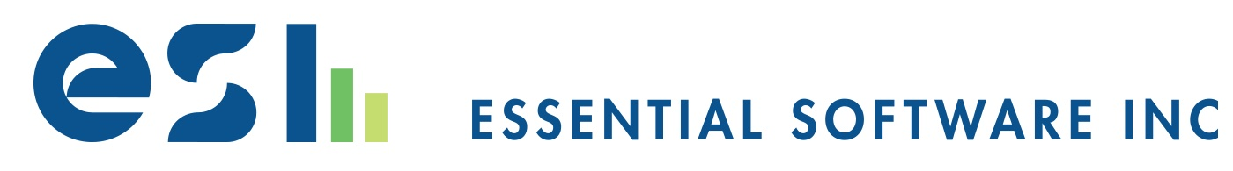

New Employee Orientation Evaluation
Choosing to start a new job is one of the more important decisions that we make in life. In doing so, we tend to be filled with excitement, anticipation, and the hope that our expectations of the job will be everything that we imagined.
But as with all important decisions in life, outcomes will vary. Sometimes our expectations are exceeded, sometimes they’re just as we had hoped, and other times they’re not what we had hoped they would be.
At ESI, it is our hope that your first 45 days with us have begun to reveal that the decision that we made to hire you—and that you made to join us—was the right decision and that your time working here is already meeting or exceeding your expectations. If it has not, then we may have some work to do.
In order to do everything that we can to meet expectations, and help you achieve success in your new position, we’d like your feedback on your first 45 days here. In asking about your start, we are interested to know your thoughts on how you are doing, how we are doing, and if things are off to as good a start as possible.
Though only 45 days into your time here, our goal is to start early in providing support to both employees, and managers, in establishing an ongoing and constant feedback loop. In doing so, we want to make sure that every employee feels equipped and encouraged in performing their jobs; advancing and affirming ESI’s core values and virtues; and ultimately, helping our clients to succeed.
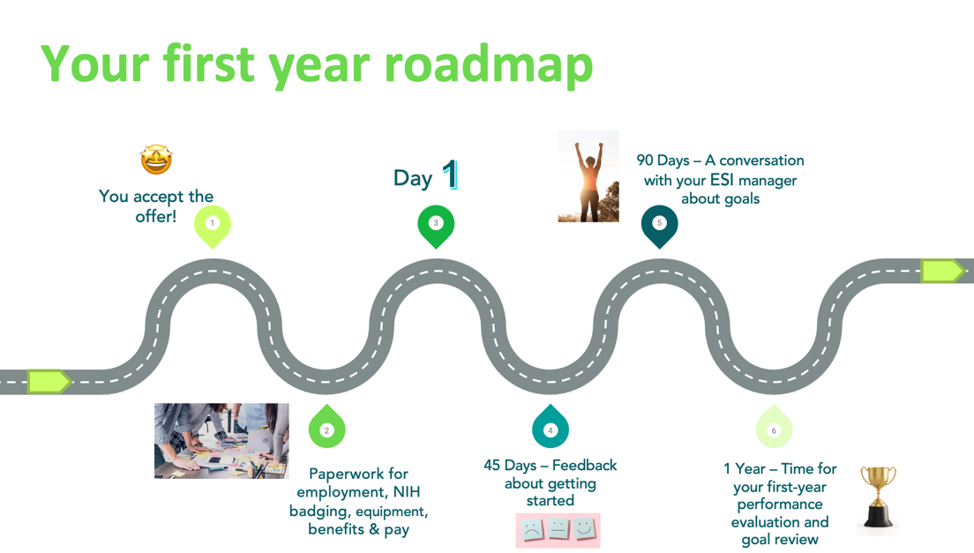

Day 45: Now that you’re here (Evaluation of Onboarding)
Please take a few moments to reflect on and answer the following questions. Specific examples of helpful or unhelpful experiences are encouraged.
Regarding Your Onboarding
- On a scale of 1-5 (5 being the highest), how would you grade ESI in terms of our extended onboarding programs (ESI company-related, NCI badging/network-related, and team/tool-related), and why?
- What was the most helpful part of your onboarding?
- What was the least helpful part of your onboarding?
- Compare the organization and your role to how we described it when you initially interviewed with us. Have you experienced any surprises, disappointments or other "aha" moments that you're comfortable sharing?
- Is there anything I can do to help you at this point and provide additional support, structure, or direction?
Regarding Your Position
- What do you like about the position so far? What's been going well?
- Do you have access to all the tools and resources necessary to do your job?
- Do you feel you've been trained sufficiently in all aspects of your job to perform at a high level?
- Is there anything you don't understand about your role?
- How has your relationship with your peers and manager developed over the last two months? Have you been made to feel welcome, and do you feel you've made others feel welcome in partnering with you?
- Have you and your manager had a chance to discuss any goals and performance metrics?
- What one thing stands out to you most in terms of capturing your first full month with us?
- Don't be shy: Tell me about some of your accomplishments thus far.

Looking Forward and Anticipating Day 90: How am I doing?
On or around your 90th day with ESI, your manager and you will meet to formally discuss your performance, and how things are going 3 months into the job. Below are 3 specific goals for you and your manager to accomplish when you meet:
- Reiterating, clarifying, and communicating how you are doing based on the performance expectations for you in your position.
- Scheduling a series of check-ins (2-3) to provide ongoing feedback on your performance over the next 9 months.
- Your manager communicating their ongoing support and availability for employee-initiated pursuit of any training, mentoring or other job-related improvement opportunities that they can recommend you pursue to help you in your job.
Goal number 1 above will be accomplished by you and your manager evaluating and reviewing the following questions:
- How are you doing in living out ESI’s 4 core values of Integrity, Collaboration, Humility, and Innovation?
- How are you doing in your interactions with and participation within your team in applying the 7 Habits as presented by the Franklin Covey model?
- How are you doing in exhibiting each of ESI’s 6 Client-facing competencies of Adaptable, Influencer, Effective Communicator Solutions-Oriented, Technically Skilled, and Quality/Quantity of Work?
- Are there any stretch opportunities or areas where you could assume additional responsibilities or gain broader exposure?
- Based on your current performance, what plans, if any, do you need to make to strengthen your capabilities in the areas of core values, client-facing competencies, and team-related virtues?
- What can I do to help you meet your goals or otherwise assist you with your own career and professional development?

Anticipating Day 365: What has been accomplished?
On or around your 1-year anniversary with ESI, your manager and you will meet to conduct your annual performance review. This will be a formal review that involves both your own, and your manager’s, formal assessment of your performance against the following 13 rating categories. This will be an opportunity for you both to look back over the course of the year and celebrate successes and observe opportunities for further growth.

CORE VALUES

INTEGRITY
True success means that our daily efforts to provide quality services and solutions to our Federal clients are achieved within a commitment to do so with the utmost integrity. Integrity comes when we gain the confidence and trust of others through principled leadership, honesty, sound business ethics, authenticity, and follow-through on all commitments.

INNOVATION
Technology is constantly improving, and so should we! For our own professional development, and for the services we provide our clients, becoming a better version of ourselves is critically important. Our people are always learning, growing, improving and innovating as they adapt to the ever-changing business and technology landscape, while daily championing new ideas, approaches, and initiatives to solving problems and delivering increased value to our clients.

COLLABORATION
Our goal is to do great things…together! Collaboration encourages working together for the good of our clients and our company.
Employees reflect this core value best when they promote and foster an environment for honest and open discussion of ideas and issues; work effectively with others across their team and the organization they support to achieve goals and objectives, and credit others for their contributions and accomplishments.

HUMILITY
Humility is the quality of being humble. Because humble people acknowledge their own personal limitations, they are better positioned to value the contributions and talents of others, and also seek to learn and grow themselves. Teamwork and collaboration will thrive in an atmosphere of humility, enabling our teams to work more effectively and consistently deliver what we promise to our clients.

COMPETENCIES: 7 HABITS OF HIGHLY EFFECTIVE PEOPLE

How are you doing in your interactions with and participation within your team with regard to the Franklin Covey 7 Habits:
HABIT 1: BE PROACTIVE – Being proactive means that you regularly choose to thoughtfully respond to circumstances and situations by taking responsibility for your behavior, actions, and results rather than focusing on things outside of your control or influence.

HABIT 2: BEGIN WITH THE END IN MIND – Beginning with the end in mind is based on the principles of vision, commitment, and purpose. Being successful in this habit means that you regularly seek to start projects, assignments and/or deliverables with a clear understanding of what you are trying to achieve as possible.

HABIT 3: PUT FIRST THINGS FIRST – Putting things first means regularly prioritizing and achieving our most important goals instead of constantly reacting to urgencies or spending too much time on unimportant tasks.

HABIT 4: THINK WIN-WIN – True and effective collaboration is the result of building high-trust relationships that focus on achieving mutual benefit amount the participants of the team and recipients of their work.

HABIT 5: SEEK FIRST TO UNDERSTAND, THEN TO BE UNDERSTOOD – Effective teams work well together when they can influence one another by developing a deeper understanding of one another’s needs and perspectives.

HABIT 6: SYNERGIZE – Teams are more effective when they strive to develop innovative solutions that leverage diversity of ideas and satisfy all key stakeholders.

HABIT 7: SHARPEN THE SAW – Continuous improvement is not just for processes, it’s also for people! To continue to be effective we should work to increase our overall motivation, energy and work/life balance by prioritizing and making time for activities that renew them.

COMPETENCIES: CLIENT-FACING

ADAPTABLE
Responds resourcefully, flexibly, and positively when faced with new challenges and demands. Moves forward productively under conditions of change or uncertainty. Actively develops one’s skills and capabilities to enhance performance and achieve personal and organizational success.

INFLUENCER
Influences and motivates others, clearly communicates appropriate information on how team members can contribute to the goals of the organization and articulates a compelling position. Positions and explains ideas and proposals in ways that get support from others.

EFFECTIVE COMMUNICATOR
Prepares and delivers clear, concise, accurate, effective, and persuasive written and verbal material/messages. Attentively and accurately listens to others. Promotes a free and timely flow of high-quality information between self and others and across the organization; encourages the open expression of ideas and opinions.

SOLUTIONS-ORIENTED
Able to understand and apply effective technical solutions to the needs/requirements of the project/client. In doing so, creates and delivers customer-centered solutions that meet as many aspects of desired customer experiences, products, and services as possible. Strives to provide customer-centered solutions that go beyond existing customer requirements. Identifies opportunities that will benefit the customer and create value-added services and works in partnership with the customer to drive the project forward.

TECHNICALLY SKILLED
Based on the level of experience, understands and effectively utilizes the technical environment (software products, tools and resources) which they work with. This may include programming languages, test tools, communications platforms, project management software, and the like.

QUALITY/QUANTITY of WORK
Able to regularly produce technical deliverables without error and free from defects or unnecessary rework. Where errors or rework do occur, is able to learn from those mistakes and eliminate making the same mistake twice.

RATING SCALE
Role Model 5.00
Employee exemplifies what is required to perform well in this core value, habit, or client-facing competency.
Exceptional 4.00
Employee regularly meets, and at times exceeds, what is required to perform well in this core value, habit, or client-facing competency.
Valued Contributor 3.00
Employee regularly meets what is required to perform well in this core value, habit, or client-facing competency.
Inconsistent 2.00
Employee struggles to consistently meet what is required to perform well in this core value, habit, or client-facing competency.
Not Effective 1.00
Employee continually fails to meet what is required to perform well in this core value, habit, or client-facing competency.

